**How to use SystmConnect Online Services**

**Step One:**

There are three ways to use the systemconnect online form:

1. Use your NHS login
2. Log-in with your SystmOnline account details
3. Continue to compete the form without logging in

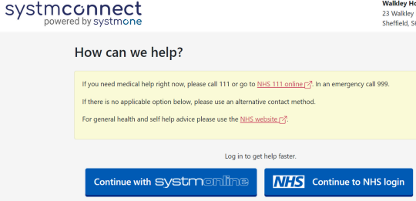

**\*PLEASE NOTE**: **By using a login, your personal details will be automatically pre-filled within the form, saving you time each time you contact us. If you choose to continue without logging in, you can still complete the form, but you will need to add all your contact information, including your NHS number, so we can confirm your identity.**

**Step Two:**

Please select the most appropriate button for the service you require:

A screenshot of adminstrative requests screen

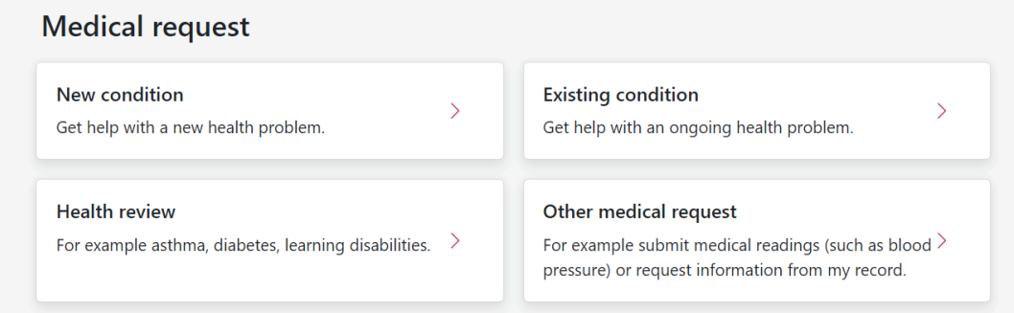**Medical Requests -** You will see 4 options for Medical Requests:

**Administrative Requests –** You will see the following options for non-medical requests:

**The following information explains the form options in more detail:**

**Medical Requests**

|  |  |  |
| --- | --- | --- |
| **Option** | **Form Opening Time** | **Information** |
| **New Conditions** |  | Please fill this in if you require help with a new health problem that you feel may need a same day response. |
| **Existing Conditions** |  | Please fill this in if you require a follow up appointment for the future or want to book a non-urgent appointment about a pre-existing health condition.  **\*\*Please note** if you think you need an appointment today, please complete the new conditions form.** |
| **Health Review** |  | Please fill this in to submit a nurse enquiry such as appointments for long term condition reviews, dressings, stitch removal, vaccinations and smears. |
| **Other Medical Requests** |  | Please fill this in if you want help with a miscellaneous clinical request. Please give as much detail as possible so that the Doctor reviewing your submission is able to process your request. |

**Administrative Requests**

|  |  |  |
| --- | --- | --- |
| **Option** | **Form Opening Time** | **Information** |
| **Register as a new patient** |  |  |
| **Doctor’s letter** |  | Please fill this in to request a letter or report. Please note, there are certain letters which are non-NHS work and will incur a private fee and we aim to complete these within 28 days. Please see ‘Services – Non-NHS Services’ for further details. |
| **Fit Note Request** |  | Please fill this in to request a sick note. A sick note is not required for the first 7 calendar of absence. For this period, you are able to self-certify. Please note, if you are well enough to return to work at your normal capacity following a period of sickness, no documentation from a doctor is required. |
| **Medication Request** |  | If you are unable to access your test results via the NHS app, please complete this form. For tests requested by the hospital, you will need to contact the consultant’s secretary for them as the result will go directly to them. |
| **Test Result** |  | If you are unable to access your test results via the NHS app, please complete this form. For tests requested by the Hospital, you will need to contact the Consultant’s secretary for them as the results will go directly to them. |
| **Other Admin Request** |  | Please fill this in if you wish to make an administrative request. |

**Step Three:**

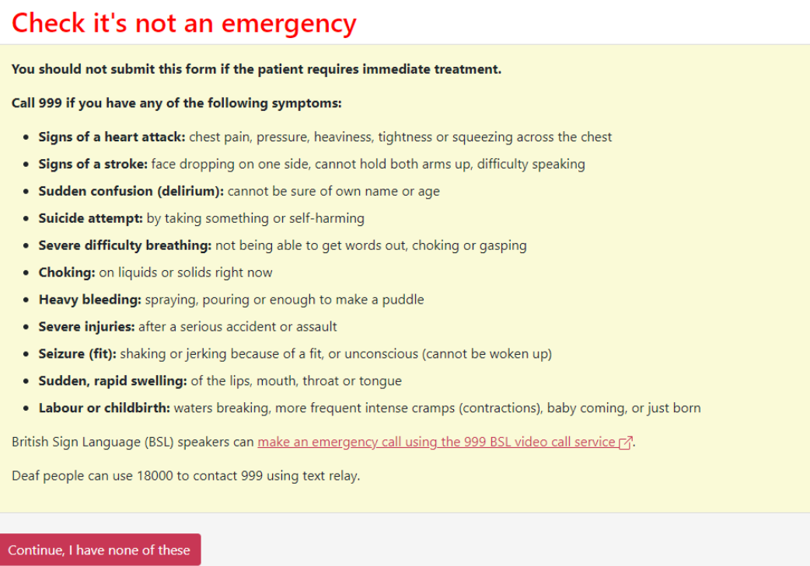You will be asked to confirm that the request is not an emergency:

**Step Four:**

Once you have confirmed that your query is not an emergency, you will continue onto the relevant information collection form for each option.

Further information about each of the form options can be found on your GP practice website.

**Step Five:**

Upon completing the requiring information, you will be asked to enter your personal and contact details**. **PLEASE NOTE\*\*** if you have logged in using your SystmOnline or NHS login credentials, your personal details should already be pre-filled.

On submission of the form, your request will be dealt with by the appropriate team member, and you will be contacted in due course.

For the most up to date information and guidance on completing the online form please visit our website _______________ or call the surgery on ______________ alternatively, you can pop in and speak to a member of the team.